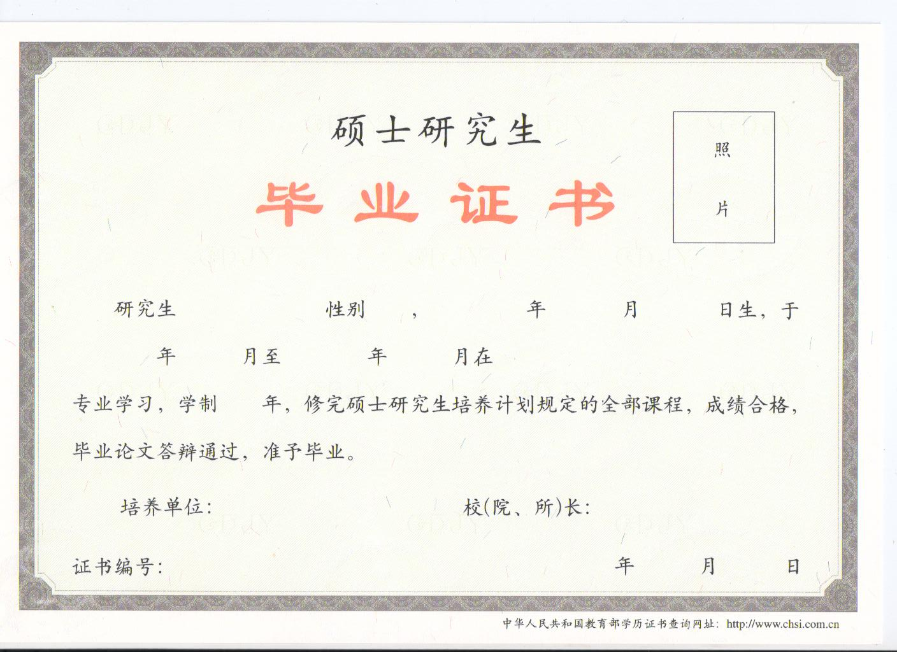

CERTIFICATE OF GRADUATION

This is to certify that 姓名, 性别, born on 出生年月日, studied in the Graduate School of Tianjin Medical University from September,年份 to July, 年份, majoring in 专业, having passed all the examinations of master（or doctor） courses and thesis defense required by the three-year graduate program, graduated in July, 年份.

Tianjin Medical University President:
Certificate No.: Date of Issue:

